Name = Abhishek Kumar

Roll no. = 1901610100011

**BINARY SEARCH**

**#include<stdio.h>**

**int main(){**

**int a[100],n;**

**printf("enter no. of elements\n");**

**scanf("%d",&n);**

**printf("enter elements\n");**

**for(int i=0;i<n;i++){**

**scanf("%d",&a[i]);**

**}**

**printf("enter search element\n");**

**int s;**

**scanf("%d",&s);**

**int first=0;**

**int last=n-1;**

**int middle=(first+last)/2;**

**while(first<=last){**

**if(a[middle]<s){**

**first=middle+1;**

**}**

**else if(a[middle]==s){**

**printf("position:%d",middle+1);**

**break;**

**}**

**else{**

**last=middle-1;**

**}**

**middle=(first+last)/2;**

**}**

**if(first>last){**

**printf("not found");**

**}**

**return 0;**

**}**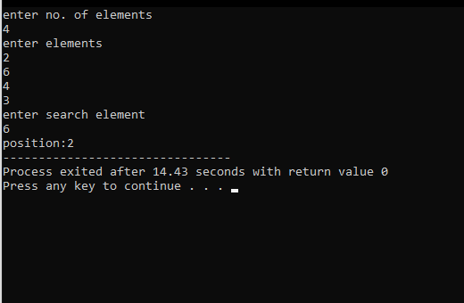

**LINEAR SEARCH**

**#include<stdio.h>**

**int main(){**

**int a[100],n;**

**printf("enter no. of elements\n");**

**scanf("%d",&n);**

**printf("enter elements\n");**

**for(int i=0;i<n;i++){**

**scanf("%d",&a[i]);**

**}**

**printf("enter search element\n");**

**int s;**

**scanf("%d",&s);**

**int f=0;**

**for(int i=0;i<n;i++){**

**if(a[i]==s){**

**printf("position:%d",i+1);**

**f=1;**

**}**

**}**

**if(f==0){**

**printf("element not found");**

**}**

**return 0;**

**}**

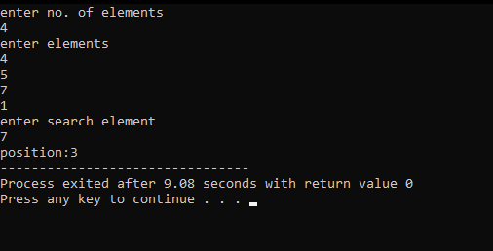

**Write a program in c to perform traversal of an array**

**#include<stdio.h>**

**int main()**

**{**

**int n, i ,a[i];**

**printf("enter the limit of array\n");**

**scanf("%d",&n);**

**printf("enter an array\n");**

**for(int i=0;i<n;i++){**

**scanf("%d",&a[i]);**

**}**

**printf(" your array \n");**

**for(int i=0;i<n;i++){**

**printf("%d",&a[i]);**

**}**

**return 0;**

**}**

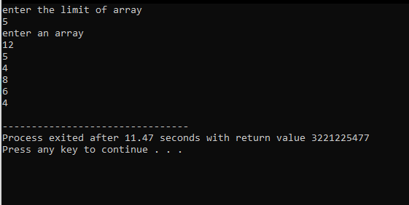

**INSERTION SORT**

**#include<stdio.h>**

**int main()**

**{**

**int i, j, count, temp, number[25];**

**printf("Enter the number of elements: ");**

**scanf("%d",&count);**

**printf("Enter %d elements: ", count);**

**for(i=0;i<count;i++)**

**scanf("%d",&number[i]);**

**for(i=1;i<count;i++){**

**temp=number[i];**

**j=i-1;**

**while((temp<number[j])&&(j>=0)){**

**number[j+1]=number[j];**

**j=j-1;**

**}**

**number[j+1]=temp;**

**}**

**printf("Order of Sorted elements: ");**

**for(i=0;i<count;i++)**

**printf(" %d",number[i]);**

**return 0;**

**}**

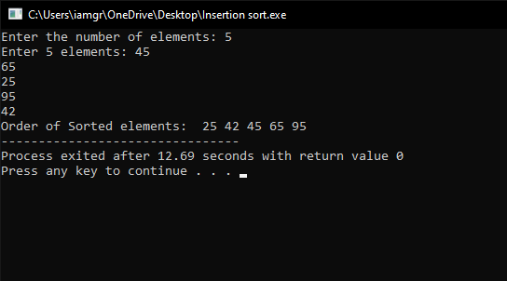

**SELECTION SORT**

**#include <stdio.h>**

**void SelSort(int array[],int n);**

**int main()**

**{**

**int array[100], n,i;**

**printf("Enter number of elements\n");**

**scanf("%d", &n);**

**printf("Enter %d Numbers\n", n);**

**for(i = 0; i < n; i++)**

**scanf("%d", &array[i]);**

**SelSort(array,n);**

**return 0;**

**}**

**void SelSort(int array[], int n)**

**{**

**int i, j, position, swap;**

**for(i = 0; i < (n - 1); i++)**

**{**

**position=i;**

**for(j = i + 1; j < n; j++)**

**{**

**if(array[position]>array[j])**

**position=j;**

**}**

**if(position != i)**

**{**

**swap=array[i];**

**array[i]=array[position];**

**array[position]=swap;**

**}**

**}**

**printf("Sorted Array:\n");**

**for(i = 0; i < n; i++)**

**printf("%d\n", array[i]);**

**}**

